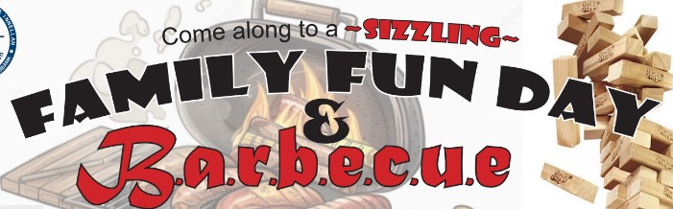

Union Suffragettes
Family Fun Day
&
Barbecue
June 14, 2025
11am to 4pm
SAVE THE DATE!!!!!!!!!!

